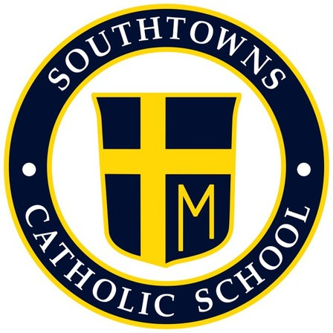
Southtowns Catholic School
Home School Association

October 2021 General Meeting Minutes
Wednesday, October 6, 6 p.m. Gym
- Call to Order- President Russell Clark at 6:10pm

- Opening Prayer- Given by Casey Hatton

- Review and approval of the Minutes- Russell Clark and Casey Hatton

- Principal Update- Marc Bandelian

- NYS guidelines will be followed regarding current Covid guidelines, which will also be posted on the school website.
- Questions regarding quarantining or other covid related questions may be emailed to Mr.
Bandelian or the school nurse who will then acquire the information from the department of health.
- Acknowledgment to Mrs. McCabe who is doing a great job in the school’s cafeteria.
With the 190 students enrolled, there are about 58 to 60 breakfasts being served, and about 100 lunches per day.
- Help is needed in the cafeteria to help monitor children, wipe down tables, and help the younger students with opening milk etc. 11:30am is the high point where volunteers may be most valuable. (Assisting with pre-k 3&4, kindergarten, and first grade students).
- Dress down day for the Catholic Charities Appeal will be held the 1st Thursday of every month, and costs $1 to participate. Dress down day includes any sports attire, however, no leggings are to be worn.
- Apologies were made for the current Frontier bussing situation. Parents are asked to call by 9am if they are picking up their children for the day.

- Treasurer Report (Given by Russell this meeting)

- The Chicken BBQ raised $100 more than last years BBQ.

- There were 320 Boxes of chocolate, Money is still being collected from the candy sales.

- Spooky Shenanigans is selling 124 tickets with a $6,000 payout

- Reports of Special Committees

- Sign-up sheets for volunteers are now available

- Trunk or Treat-
Date: October 22 from 6-8pm

- There will be volunteers at each entrance to help guide traffic
- Those who will be decorating their trunks, may arrive by 4pm but MUST arrive at the school by 4:45pm. The parking lot will close at 5:45pm. All others are asked to park on the side roads and behind the parish. Those who are decorating trunks MUST stay until 8pm to avoid any accidents and confusion.
- All participants handing out candy must wear masks and gloves.
- Make sure to come prepared for candy handout, as there usually are two major pushes of people around 6 and 7 pm.
- Bathrooms will be open in the school, volunteers are needed to take shifts to monitor bathrooms. Cleaning schedule needs to be established still as well.
- Lakeshore Fire Department will be present.
- The Great Aussie Bite food truck will be present.
- A sound/PA system are still needed.
- Awald farms is donating 50-70 small pumpkins that will be handed out first come first serve to the younger participants.

- Spooky Raffle- Given by Brian Pacillo

- It was brought to the attention that some people may not be comfortable purchasing tickets online.
- Volunteers are needed to help sell online tickets after masses.
- Father Sean needs to be updated so he can announce at masses. (4:30, 6, 8, 9:30, and 12)
- Credit card swipe may be helpful

- Mother / Son Dinner- Given by Sherry Miller and Husband

- Plans for the mother/son dinner includes 4:30 mass followed by a spaghetti dinner and nerf war.
- It will be $5/6 for the dinners.
- Social distancing standards will need to be considered while making decisions regarding the location of the dinner/nerf war.
- Volunteers are needed for spaghetti dinner set up and cleanup.

- Bulb Sale- Given by Susan Langley
- 1,200 bulbs will need to be bagged and separated into 200 bags of 6 bulbs each. The bags will be sold for $5 a bag.
- Bulbs will be sold after masses on the (16 and 17th) and there will be a table set up at Trunk or Treat for the community to purchase.
- If all are sold there will be a $1,000 profit.
- Dolly V is the donor of the bulbs

- Thanksgiving Food Drive
- November 1st food will begin to be collected. Every grade level will be asked to give one type of food item (ex. Green beans). Collection goes until November 21st.
- November 22nd, HSA will sort the food and bring to 7 or 8 families who need the meals.

- Santa’s Secret Shop- Given by Marc Bandelian
- .HSA will have initial purchase of items for shop.
- December 13-15th will be held in the community room.
- There will be $1 and $2 items for parishioners who would like to come purchase gifts for their children/grandchildren etc.
- Students will be able to come to purchase items for their loved ones.
- Last year’s gifts were purchased from 5 Below.
- Volunteer help is needed.

- Operation Christmas Cheer- Given by Marc Bandelian and School Board Members
- Collection for Southtown Catholic families in need
- Visa gift cards or any donations will be accepted
- Carol Mullens will put families in the giving tree (parish as well) if there are not enough donations collected. The parish giving tree goes up in November and ends before Christmas time (usually the second week of December).

- Open Announcements/Community
- Wreath sale- Will no longer be a fundraiser at this time.
- Room parents are needed for all grade levels.
- Lisa and Jenna are chairing the little pantry in front of the church. They are asking for donations to keep the pantry stocked. (Non-perishable items, personal care items, dog/cat food etc.) No glass items please.
- Veteran’s day celebration is up in the air at this point.
- Scholastic Book fair possibly back in operation in 2022, still needs approval.
- Marian Fund was discussed, no longer in place at this time.
- Script Cards- in the process of changing coordinators. An order was put in to fill the book, will hopefully be in by 10/7 or 10/8 in the parish office. The school is now getting a book so that parents can get cards too. Script cards can go online too, talk of increase in advertisement.

- Adjournment- Given by Russell Clark
Meeting ended at 7:15pm

