ACCEPTABLE UNIFORM DRESS SHOES
BOYS- Grades 2-8- Black or brown leather or leather-like. May be loafer style, top-sider or boat shoes, or oxford –style tie shoes.
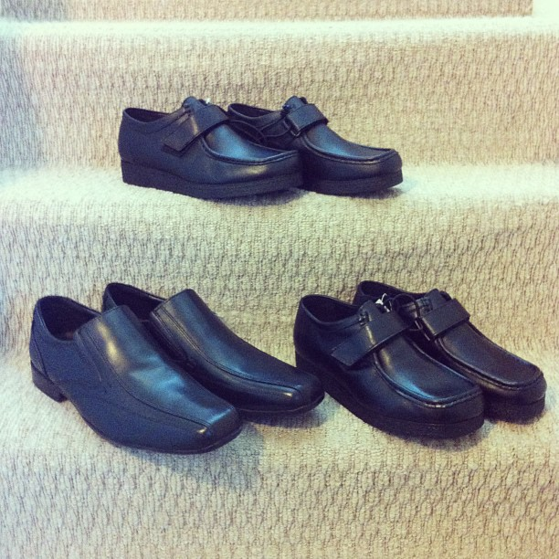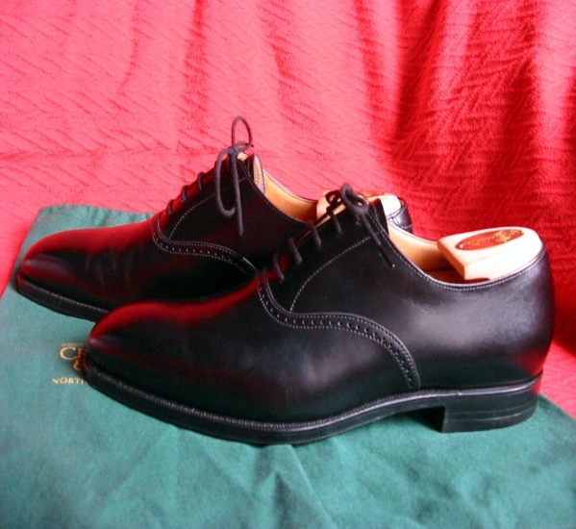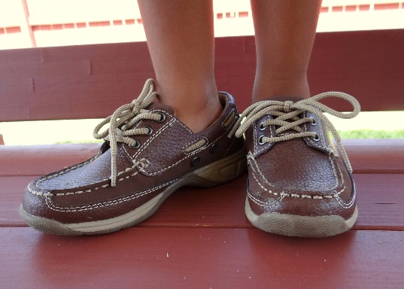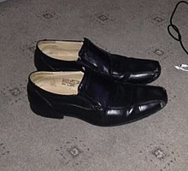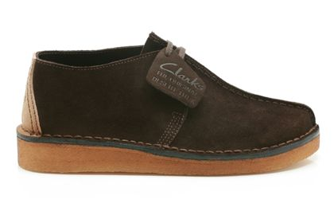
PLEASE NOTE: SNEAKERS ARE ALLOWED ONLY ON GYM DAYS OR DRESS DOWN DAYS.
GIRLS- Black, brown, or navy leather (or leather-like). May be loafer style, ballet-flat style, Mary Janes, or oxford style tie shoes. The following are example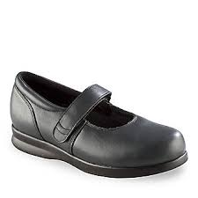 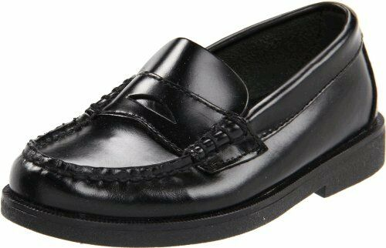
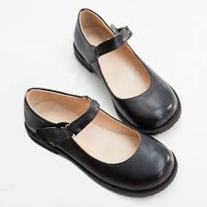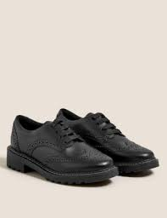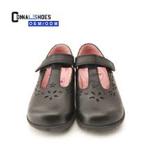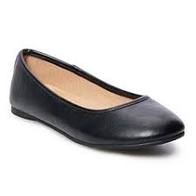
PLEASE NOTE: SNEAKERS ARE ALLOWED ONLY ON GYM DAYS OR DRESS DOWN DAYS.

