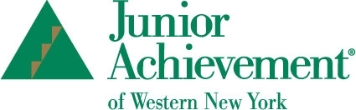
Volunteers Needed!
Junior Achievement volunteers are needed in WNY area schools. JA seeks volunteers from the business community to present their financial literacy, work readiness and entrepreneurship focused programs to students in grades K-12 (varies by school). All presenting materials, including scripted lesson plans and training, are provided to volunteers. Presenters are encouraged to bring their own experiences and careers into their sessions. Each JA program involves a series of lessons, at a schedule that is mutually agreed upon by teacher and volunteer. Junior Achievement helps to connect the classroom to the real world! For more information or to get involved, please contact Alycia Ivancie, JA Senior Education Manager, at aivancie@jawny.org or (716) 853-1381 ext. 215. Additional information can also be found at www.jawny.org

