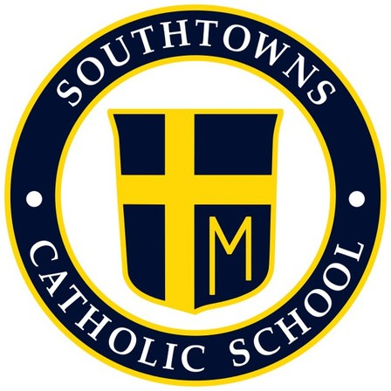
Southtowns Catholic School
Home School Association

November 2021 General Meeting Minutes
Wednesday, November 3, 6 p.m. Gym
- Call to Order- President Russell Clark at 6:15pm

- Opening Prayer- Given by Natalie Zorn

- Review and approval of the Minutes- Russell Clark and Natalie Zorn

- Principal Update- Marc Bandelian (given by Natalie Zorn)

- Review of Ribbon Week being extended to this week. Friday, November will be “Lei Off Drugs”
- Pre-K and Kindergarten Readiness celebrated their Halloween parties Wednesday, November 3rd. K-8th will celebrate Thursday. Kids can wear costumes to school, but no masks. Parties are being held in classrooms in afternoon.
- Dismissal procedures in the afternoon: remember to have cars with car seats pull up on the inside lane so it’s easier for the kids to get in.
- Thanksgiving Food Drive is ongoing
- Thanksgiving Break- November 24th-26th

- Treasurer Report

• The Chicken BBQ raised $1,939.90
• Spooky Shenanigans raised $1,576.56
• Bulb Sale raised $490.00
• United $165.34
• SEFA $121.30
• Current Candy Bar Sale $3,327.35
• Script Cards and Bottle Return sales are not included yet (waiting for check from bottle
return)

- Review of Recent Events (Russ Clark)
  - Trunk or Treat- Oct 22
    - Sustain- Traffic control was great (centralized). Restrooms supervision worked well (maybe more volunteers next year). Lining the kids up before was good, but maybe start 2 lines at opposite ends of parking lot so there’s not a backup
    - Improve- End 30 mins earlier. Add a costume contest (group or individual), trunk contest. See when competitors are doing their trunk or treat- Pinehurst did theirs the same night. Maybe charge $1 per trunk and that can go towards the prizes.
** When promoting, let trunks know it’s about 550 pieces of candy

- Spooky Shenanigans Sweepstakes
- Sustain- Easy to buy tickets. Reasonable prices
- Improve- Prizes need to be smaller

- Fall Bulbs
  - Sustain- Donation. Money maker no matter what
  - Improve- Order bulbs sooner, sell a little earlier in the fall

- Reports of Special Committees
  - Mother/Son Mass and Dinner Nov 20 (Sherry Miller)
  - Thanksgiving Food Drive Nov 1-19 (Natalie Zorn)
    - Get the students to help distribute the food into boxes for volunteer hours on the 22nd
  - Santa’s Secret Shop Dec 13-15 (Lauren Lobur)
    - Lauren will come in and get an inventory of the HSA closet to see what we still have for the sale. We need to get a budget for shopping. We also need to make a shopping list for the kids to take home and mark off the budget and who they’re buying for

- Unfinished Business
  - Veteran’s Day Celebration Nov 10
    - Color guard is coming in and playing the song for each branch of the military. Kids can stand for each member of their family during that song. We’ll then go outside for 21 gun salute. Unfortunately this is a closed event
  - Operations Christmas Cheer Dec 6-17
    - School will collect gifts for deserving families (toys, clothes, gift cards). HSA will distribute
- New Business
  - Holiday Comedy Show Nov 30, 6-9pm (Russ Clark)
    - Comedian will be coming in. Held in Community Room. Free. Food and soft drinks will be provided. 50/50 raffle. Adults only BYOB.
  - Meat Raffle January 15
    - Need a chair and start putting a committee together
  - Easter Candy Sale January 25th
    - Last year we used Niagara Candy. We should look into Gertrude Hawk or Fowlers for this year.
  - Gala
    - Work together with Parish. Get committee together asap
- Open Floor
• We are still in need of a 7th grade room parent
- Adjournment (Russ Clark)

